**DSA Assignment – 14th July**

**Name – Rahul Goswami**

**Roll No. – 23/11/EC/053**

**Leetcode Id – MrPBH**

**Geeksforgeeks Id – clockwo906p**

**Github Repo Link –**

<https://github.com/Rahu1Goswami/PlacementTraining2025>

1. Inorder Traversal

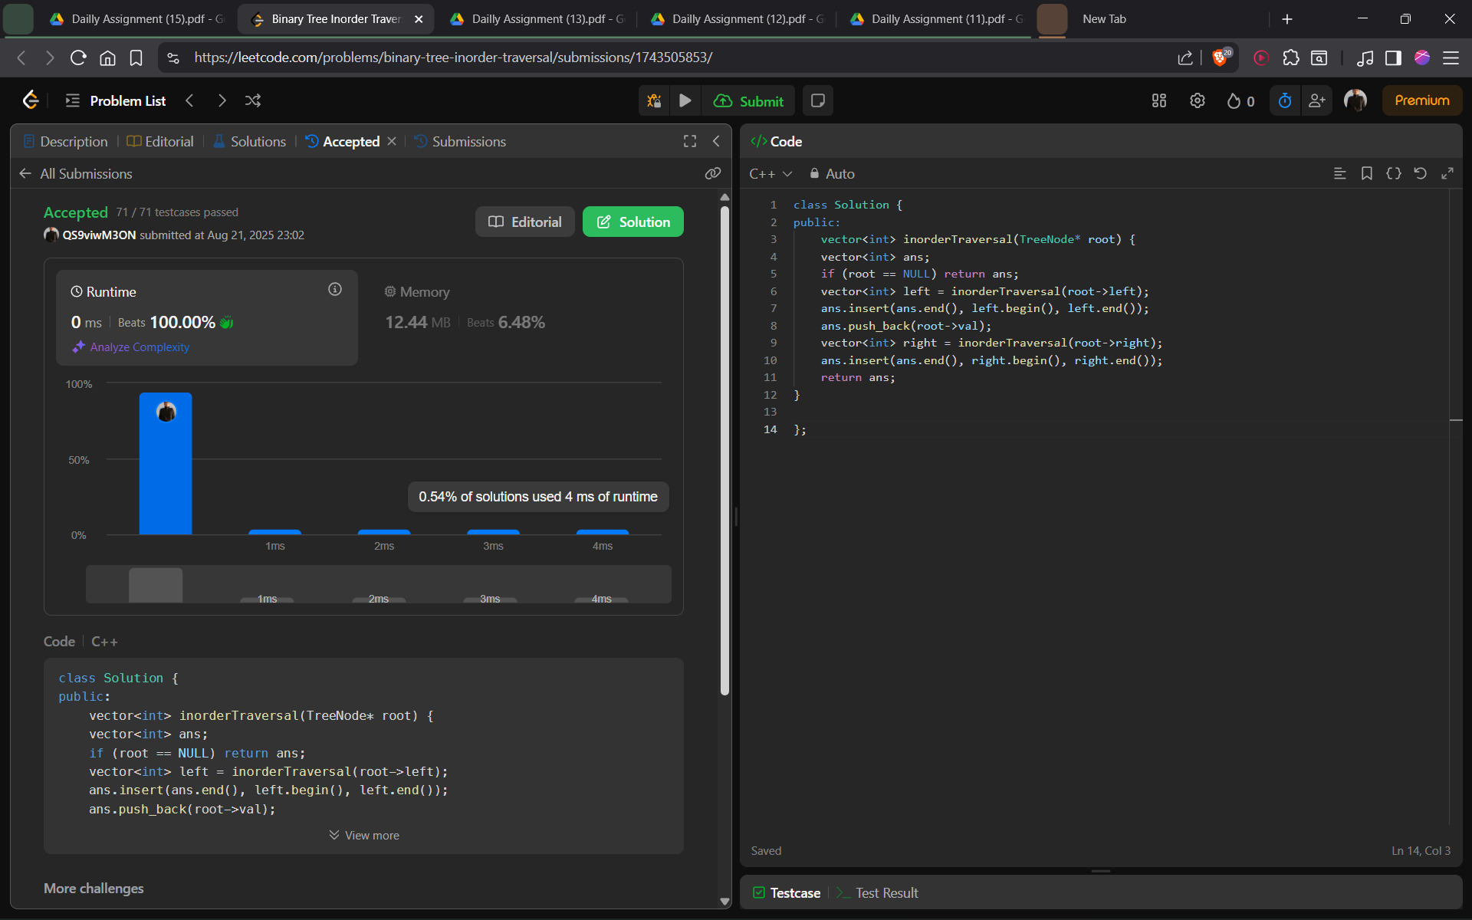

1. Level Order Traversal

1. Maximum of Binary Tree

1. Diameter of Binary Tree

